Skin Graph-T 6/24/15

Technical Writer: Charlie Goldschmiedt

Engineer: Mitchell Mikinski

Conductor: Mitchell Mikinski

Reporter: Dean Gladish

You did a lot of good work today, and generated some interesting examples. However, some of your proofs either include pretty big logical errors, or don’t really answer the questions asked. If you’re not sure about a proof (or even if you are!) try explaining your ideas to me or to Lizzy before writing them up. If you’re not sure how much to write, imagine you are explaining the solution to a less-experienced student, who doesn’t understand graph theory as well as you do; your solution should be clear and detailed enough for that person to understand what you mean.

--RK

We were particularly proud of our solution to numbers 5 and 2.

Morning Report: In the morning session, we discussed the homework from Tuesday, attempting to redo the problems 4, 9, and 10. We then went through the Ore sufficiency condition, using the concept of finite vertices to prove that the graph G must be Hamiltonian. Following this we discussed necessary and sufficient conditions for both Eulerian and Hamiltonian graphs. We covered the G-S property of a graph: G-S ⪬ S where the values are components. Nice summary.--RK

Afternoon Report: During the afternoon session, we worked as a team, and decided to tackle the problem one, before moving on to problem two. Problem one was rather difficult for us, so after we attempted it a number of times, we moved on to problem two. We worked quite hard on number two, without a solution, and then someone asked, “Have we checked the Petersen Graph?” We immediately did so, and sure enough, it was our solution. Problem three was not particularly difficult. We realized that a sufficient result could be realized by following the definition and properties of a cycle. Problem four was, by far, the easiest problem we did. It was reading definitions and realizing the “real world equivalent” of what they were saying. It is probably good that we found this one easy, as it had the most practical applications of the problems we answered. Problem five was the hardest problem we answered. We toiled away for the remaining class time. Mitchell came up with our answer, right before we left to begin typing up our report. He was very happy. We eventually came back to number one. We came up with an answer. It’s great that you’re working hard on the problems, and having fun! Skipping around a bit on the problem sets, as you did today, can be a good strategy.--RK

H.W. #3

1. The degree sum must be at least 6, as a cycle can only be made with at least 3 vertices and each vertex must have a degree of at least 2.

- This does not answer the problem. You needed to find a necessary and sufficient condition. Your answer does not outline what is necessary nor what makes it sufficient. While your answer is technically correct, it is confusing to read at first. Ask Rachel and I next time to help you with writing a formal proof. Since you tried to leave early and this was your answer, improvement needs to be made to your homework. - Lizzy

2. Given that the Petersen Graph is not Hamiltonian, but is 2 connected, we can gather that being 2 connected is not a sufficient condition for making a Hamiltonian graph. A Hamiltonian graph cannot have a cut vertex, therefore in order to keep from having a cut vertex, a Hamiltonian graph must be at least 2 connected.

You gave a correct, airtight proof that a Hamiltonian graph must be at least 2-connected. Great work! You do need to explain why the graph the Peterson graph is 2-connected; this isn’t something we can assume without proof.--RK

3. By definition, the vertices of a cycle must all have at least 2 edges (degree 2) in order to be considered a cycle. First, we define a graph G in which each vertex has at least degree 2. If we begin with a vertex, we can assume that this vertex will have a neighbor as its degree is at least 2. This neighbor will also have a neighbor, and so on. As a graph cannot have infinite vertices, a vertex must be connected to another one in the same graph. Therefore, a cycle would be created in which no vertices are repeated. This cycle would be a Hamiltonian cycle.

This argument isn’t correct. You do get a cycle, but it may not be Hamiltonian. Try some examples and see this for yourselves!--RK

Since a cycle is sufficient to create a Hamiltonian graph, we can deduce that each vertex must have a degree of at least “N/2”, on a Hamiltonian graph, because the lowest number of vertices a cycle can have is 3. “3/2” would equal 1.5, which rounds up to two, meaning that the minimum number of edges each vertex can have is 2.

I like that you noticed we can “round up” here, and that 2 is “at least 3/2”. But this paragraph doesn’t make sense, and you “prove” something false. For example, a 6-cycle is a Hamiltonian cycle, but not every vertex has degree “at least N/2”. Do you see why?--RK

4. Connected- given that all train stations are connected to each other it is possible to travel to every station on a series of paths.

Dr Bloomquist may not know what you mean by a path - Lizzy

Hamiltonian- each vertex is used in a cycle exactly once. Meaning, one can visit every train station and return to the starting position/station without visiting the same station twice.

Eulerian- A trail using all edges. Meaning, one can travel across every train track without touching the same piece of track twice, and returning to the starting position/station using a different track.

5.

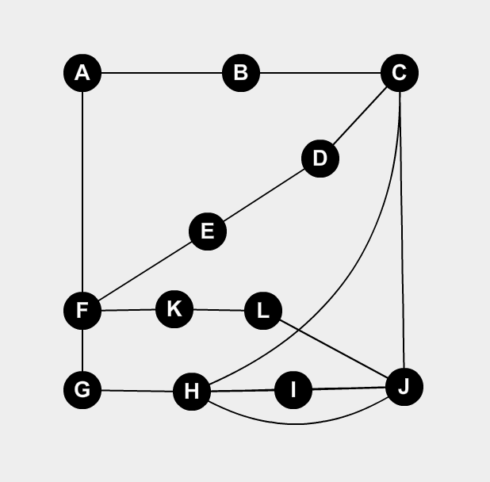

Close, but not quite. It is Eulerian and not Hamiltonian, but the removal of vertices C,G would cause it to fail G-S. - Lizzy

6. Did not get to it.

You had extra time, you could have worked on this. - Lizzy